SIMATS ENGINEERING
ASSESSMENT TOOL 1

COURSE NAME: Artificial Intelligence COURSE CODE: CSA17

COURSE OUTCOME COVERED

CO1: Apply AI basics such as intelligent agents and uninformed search methods to solve problems effectively. (BL3)

Assessment Tool Weightage: 50%

QUESTIONS: 5 Duration : 1 Hour
Total Marks:50

Annexure A

Analytical Problem Solving

Code of Conduct:

I ABHINAV CHARLES (192524168)(Name / Reg No) certify that this submission is my original work and that I have adhered to the guidelines specified for this assessment.
I understand that any violation of academic integrity rules will result in disciplinary action.

Signature of the student:
ABHINAV CHARLES

Annexure A

Analytical Problem Solving

- Solve the Water Jug problem: you are given 2 jugs, a 4-gallon one and 3-gallon one. Neither has any measuring maker on it. There is a pump that can be used to fill the jugs with water. How can you get exactly 2 gallons of water into 4-gallon jug? Explicit assumptions: A jug can be filled from the pump, water can be poured out of a jug onto the ground, water can be poured from one jug to another and that there are no other measuring devices available.

Answer: 1. Problem Statement
We are given two jugs: one with a capacity of 4 gallons and another with 3 gallons. Neither jug has measuring marks. The objective is to obtain exactly 2 gallons in the 4-gallon jug using a water pump and the allowed operations.

2. Initial State
- Jug A = 4 gallons
- Jug B = 3 gallons
- Initial state = (0, 0)
- Goal state = (2, 3)
The state is represented as (A, B), where A and B denote the water quantities in the two jugs.

3. Operators
- Fill a jug completely.
- Empty a jug onto the ground.
- Pour water from one jug into another until the source is empty or the destination is full.

4. Step-by-Step Solution
Step | Operation | Jug A | Jug B
1 | Initially, both jugs are empty | 0 | 0
2 | Fill Jug A | 4 | 0
3 | Pour A into B until B is full | 1 | 3
4 | Empty Jug B | 1 | 0
5 | Pour A into B | 0 | 1
6 | Fill Jug A again | 4 | 1
7 | Pour A into B until B is full | 2 | 3
Result: Jug A contains exactly 2 gallons of water.

5. State-Space Representation
(0,0)→(4,0)→(1,3)(0,0)\rightarrow(4,0)\rightarrow(1,3)(0,0)→(4,0)→(1,3)
→(1,0)→(0,1)→(4,1)→(2,3)\rightarrow(1,0)\rightarrow(0,1) \rightarrow(4,1)\rightarrow\boxed{(2,3)}→(1,0)→(0,1)→(4,1)→(2,3)​

6. Algorithm
- Fill the 4-gallon jug.
- Pour water into the 3-gallon jug until it is full.
- Empty the 3-gallon jug.
- Transfer the remaining water into the 3-gallon jug.
- Refill the 4-gallon jug.
- Fill the remaining space in the 3-gallon jug.

7. Conclusion
The Water Jug Problem is a classical Artificial Intelligence state-space search problem. By using filling, emptying, and pouring operations, we obtain exactly 2 gallons in the 4-gallon jug without using measuring devices

- Find out how Mars Rover, analyse and explore the samples on Mars by answering the following questions.
- What are the percept’s for this agent?
- Characterize the operating environment.
- What are the actions the agent can take?
- How can one evaluate the performance of the agent?
- What sort of agent architecture do you think is most suitable for this agent? Why?

Answer: A Mars Rover is an autonomous robot designed to explore the surface of Mars, collect samples, analyze rocks and soil, and send scientific data to Earth.

i. What are the percepts for this agent?
Percepts are the information received by the rover through its sensors.
- Images of rocks, soil, and surroundings from cameras.
- Distance and obstacle information from sensors.
- Temperature, pressure, and environmental conditions.
- Chemical composition of rocks and soil from scientific instruments.
- Rover position, speed, and battery level.

ii. Characterize the operating environment.
The Mars Rover operates in the following environment:
- Partially observable: It cannot observe the entire Martian surface.
- Deterministic or stochastic: Movement and environmental outcomes may be uncertain.
- Sequential: Each action affects future decisions.
- Dynamic: Environmental conditions may change.
- Continuous: Movement, time, and sensor readings vary continuously.
- Single-agent: The rover performs its mission independently, although communication with Earth supports its operation.

iii. What are the actions the agent can take?
- Move forward, backward, and turn.
- Capture images and scan the surroundings.
- Collect rock and soil samples.
- Analyze samples using scientific instruments.
- Avoid obstacles and select safe routes.
- Transmit collected data to Earth.
- Manage battery power and enter a safe mode when required.

iv. How can one evaluate the performance of the agent?
The rover's performance can be evaluated based on:
- Number of useful samples collected and analyzed.
- Accuracy of scientific measurements.
- Distance explored successfully.
- Ability to avoid obstacles and prevent damage.
- Efficient use of battery power and time.
- Amount and quality of useful data transmitted to Earth.

v. What sort of agent architecture is most suitable? Why?
A model-based, goal-based, and utility-based agent architecture is most suitable for the Mars Rover.
- Model-based: Maintains an internal map of the environment.
- Goal-based: Plans actions to reach exploration targets and collect samples.
- Utility-based: Chooses safer and more efficient actions based on scientific value, risk, and energy consumption.
- Learning capability: Improves navigation and decision-making using previous observations.
Reason: The Mars environment is uncertain and communication with Earth is delayed. Therefore, the rover needs to make independent decisions, plan routes, avoid hazards, and achieve scientific goals efficiently.

Conclusion
The Mars Rover is an intelligent autonomous agent that uses sensors to perceive its environment, performs actions to explore Mars, and evaluates its performance through scientific discoveries, safety, and resource efficiency.

- Explore the search space using search strategies and formulate the problem components for the 8-Queens problem using the following information: Place 8 queens on a chessboard such that none of the queen’s attack any of the others. A configuration of 8 queens on the board as shown in the figure below, but this does not represent a solution as the queen in the first column is on the same diagonal as the queen in the last column.

Answer:
Problem formulation (incremental).
Component | Definition
States | Any arrangement of 0 to 8 queens on the board such that no queen attacks another (one queen per column, filled from the left)
Initial state | Empty board – no queen placed
Actions | Add a queen to the leftmost empty column in a row where it is not attacked by any queen already on the board
Transition model | Returns the board with the new queen added
Goal test | 8 queens are on the board and none attacks another (no two share a row, column or diagonal)
Path cost | Not important – only the final arrangement matters (every step costs 1)

Attack test. Queens at (row r1, col c1) and (r2, c2) attack each other if r1 = r2 or |r1 − r2| = |c1 − c2|. In the given figure the queen in the first column and the queen in the last column lie on the same diagonal, so it is not a solution.
State-space size and search strategy.
Formulation | Number of states
Complete-state: any 8 queens on any squares | 64C8 ≈ 4.4 × 10⁹ (64⁸ ≈ 2.8 × 10¹⁴ if queens are placed one by one)
One queen per column, any row | 8⁸ = 16,777,216
Incremental, no queen attacked (above) | Only 2,057 states in the whole tree

– Depth-first search with backtracking is the best uninformed strategy: all solutions lie at depth 8, so DFS reaches one quickly and needs memory only for the current path (O(bm)). When a column has no safe row, it backtracks to the previous column and moves that queen.
– Breadth-first search is complete but must store a whole level of the tree, so its memory demand is much larger. Depth-limited search with limit 8 avoids infinite paths.
Solution found. Rows of the queens for columns 1 to 8 are 1, 5, 8, 6, 3, 7, 2, 4. No two queens share a row, column or diagonal. The puzzle has 92 solutions in total (12 distinct up to rotation and reflection).
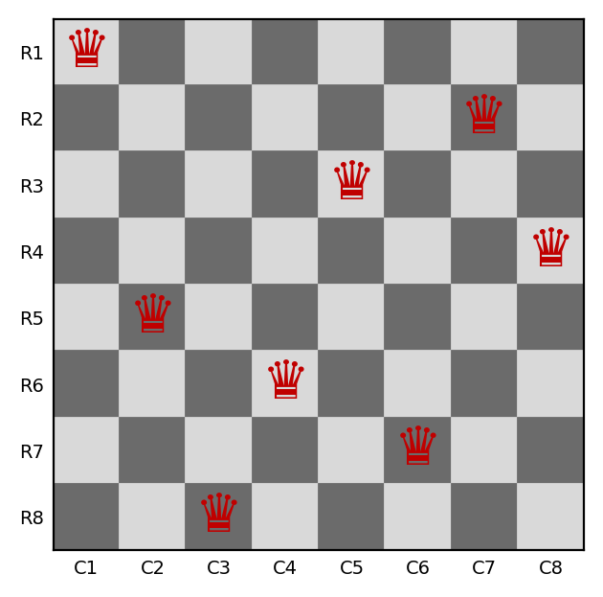

- A customer wants to travel from the one location to another location using OLA Cab booking mobile application. The customer can select the any of the cab type as mini, micro, sedan, shared, prime and so on based on his comfort to reach the destination. Identify what type of problem-solving agent can be used and write the pseudocode for the above problem.
Answer:

1. Problem Statement
A customer wants to travel from a source location to a destination using the OLA cab booking application. The customer can select different cab types such as Mini, Micro, Sedan, Shared, or Prime based on comfort, cost, and availability.

2. Type of Problem-Solving Agent
A Goal-Based Problem-Solving Agent can be used for this problem.
Reason:
- The agent identifies the customer's destination as the goal.
- It searches for available cabs and suitable routes.
- It considers cab type, fare, travel time, and availability.
- It selects a suitable option to reach the destination.
- It executes the booking after the customer confirms the selection.

3. Problem Formulation
- Initial State: Customer is at the source location.
- Goal State: Customer reaches the destination.
- Actions: Select cab type, book a cab, choose a route, and travel.
- Transition Model: The customer moves from the source to the destination through the selected cab and route.
- Path Cost: Fare, travel time, and distance.
- Goal Test: Check whether the customer has reached the destination.

4. Pseudocode
BEGIN

INPUT source_location
INPUT destination_location

IF source_location = destination_location THEN
PRINT "Already at destination"
STOP
END IF

DISPLAY available cab types
Mini, Micro, Sedan, Shared, Prime

INPUT preferred_cab_type

SEARCH for available cabs

IF cab is available THEN
CALCULATE estimated fare
CALCULATE estimated travel time
DISPLAY fare and travel time

IF customer confirms booking THEN
BOOK cab
FIND suitable route
START trip

WHILE destination not reached DO
FOLLOW route
UPDATE current location
END WHILE

PRINT "Destination reached successfully"
ELSE
PRINT "Booking cancelled"
END IF

ELSE
PRINT "No cabs available"
END IF

END

5. Conclusion
A Goal-Based Problem-Solving Agent is suitable for the OLA cab booking application because it identifies the destination as the goal, searches for available cabs, selects a suitable route, and helps the customer reach the destination. Cost and travel time can also be considered when selecting the best option.

- A logistics company operates a delivery network where packages must be transported between warehouses at minimum cost. Each route between warehouses has an associated travel cost (fuel + time). The company wants to determine the least-cost path from the starting warehouse S to the destination warehouse G using the Uniform Cost Search (UCS) algorithm.
The delivery network is represented as a weighted graph:
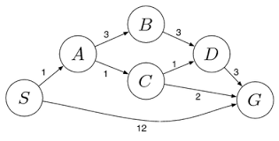
Answer:
Problem formulation: Initial state = S; Goal state = G; Actions = travel along a directed edge; Step cost = edge weight (fuel + time). Edges: S→A 1, S→G 12, A→B 3, A→C 1, B→D 3, C→D 1, C→G 2, D→G 3. UCS always expands the node with the lowest path cost g(n) from a priority queue; the goal test is applied when a node is removed from the queue.
Step | Node expanded (g) | Children generated (cost) | Priority queue after the step
0 | – | – | S(0)
1 | S (0) | A = 0+1 = 1; G = 0+12 = 12 | A(1), G(12)
2 | A (1) | B = 1+3 = 4; C = 1+1 = 2 | C(2), B(4), G(12)
3 | C (2) | D = 2+1 = 3; G = 2+2 = 4 (better than 12, so updated) | D(3), B(4), G(4)
4 | D (3) | G = 3+3 = 6 (worse than 4, discarded) | B(4), G(4)
5 | B (4) | D = 4+3 = 7 (worse than 3, discarded) | G(4)
6 | G (4) | Goal test passed – stop | –

Order of expansion: S, A, C, D, B, G.
Least-cost path: S → A → C → G with total cost = 1 + 1 + 2 = 4.
Other paths compared: S→A→C→D→G = 1+1+1+3 = 6; S→A→B→D→G = 1+3+3+3 = 10; S→G = 12. All are costlier than 4.
Interpretation: The company should route the package through warehouses A and C, spending a minimum of 4 cost units (fuel + time) instead of 12 on the direct route, saving about 67% of the cost. UCS is complete and optimal when every step cost is positive, so this path is guaranteed to be the cheapest.

RUBRICS FOR CALCULATION:
Criteria | Weightage | Level 4 (Exemplary) | Level 3 (Proficient) | Level 2 (Developing) | Level 1 (Beginning)
Problem Understanding | 20% | Clearly interprets problem, identifies all parameters and requirements accurately | Understands problem with minor gaps | Partial understanding; misses key elements | Misinterprets or unable to understand problem
Method Selection | 20% | Selects most appropriate method/formula with strong justification | Selects correct method with minor errors | Inappropriate or partially correct method | Unable to select method
Solution Process | 25% | Logical, systematic steps with correct approach throughout | Mostly correct steps with minor mistakes | Disorganized steps; multiple errors | No clear process
Accuracy of Calculation | 20% | All calculations accurate; correct final answer | Minor calculation errors | Frequent errors; incorrect final answer | No valid calculations
Interpretation of Results | 15% | Clearly interprets results with units and engineering relevance | Basic interpretation with minor omissions | Limited or unclear interpretation | No interpretation
Problem Understanding | 20% | Clearly interprets problem, identifies all parameters and requirements accurately | Understands problem with minor gaps | Partial understanding; misses key elements | Misinterprets or unable to understand problem

